**EXPERIMENT 10 – TRIGGERS**

**show databases;**

**use db;**

**show tables;**

**create table test(name varchar(2) primary key, marks int);**

**desc test;**

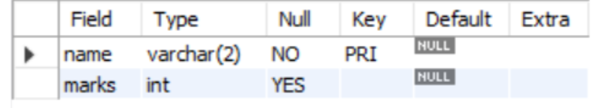

**insert into test(name, marks) values("LS", 24);**

**insert into test(name, marks) values("CH",25);**

**insert into test(name, marks) values("RK",23);**

**select * from test;**

**create table test_audit(name varchar(2), marks int);**

**desc test_audit;**

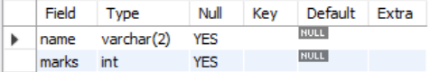

**create trigger t**

**before insert on test**

**for each row**

**insert into test_audit set name = new.name,**

**marks = new.marks + 10;**

**insert into test values ("OP", 12);**

**show triggers;**

**select * from test;**

**update test set name = "AP" where name = "OP";**

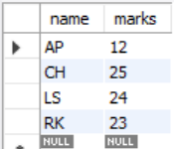

**select * from test_audit;**

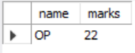

**show triggers;**

